**Milestone 2 UI/UX Storyboards**

**Casual:**

Emily:

* 1. A casual user, Emily, wants to cook something at home but she doesn’t know what she can cook and is not familiar with recipes. She goes onto cookable to find possible recipes she can cook with the food only in her fridge. She finds that she can make a lot of different food with the simple ingredients in her fridge.

She Logs in to Cookable:

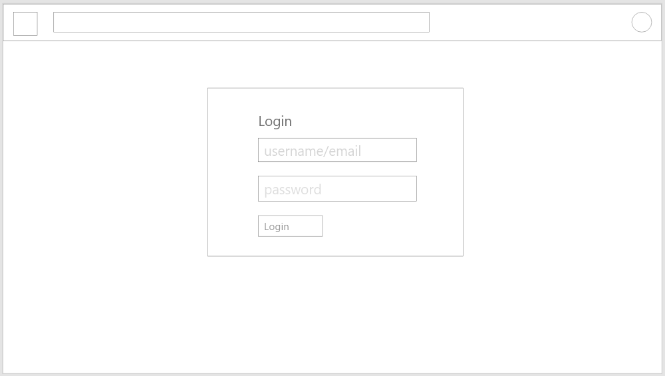



Searches for Recipes:

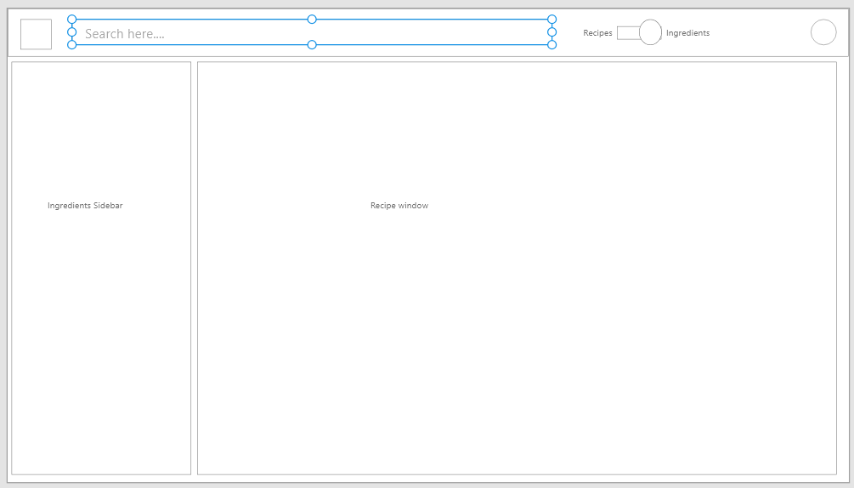

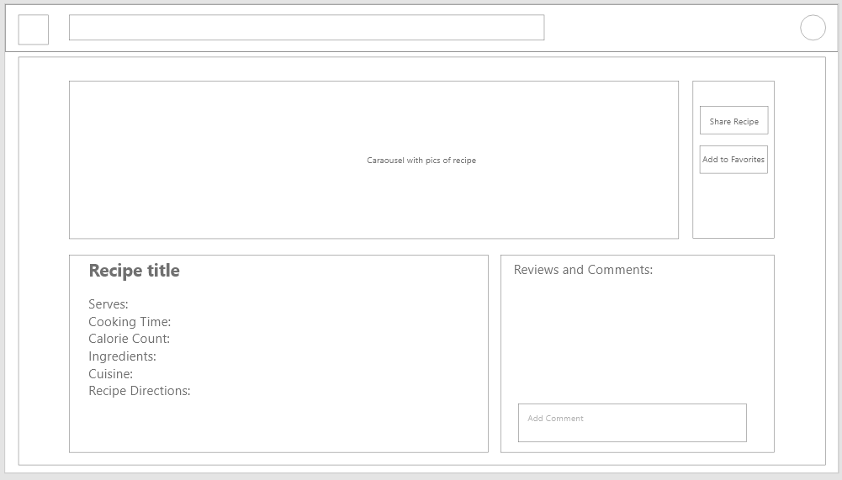Clicks on a Recipe, opens a new recipe page

2) Emily is at the grocery store and she wants to cook something at home but doesn’t know what to get. Her budget is limited as well so she can only buy cheap ingredients. She opens the website and enters in the ingredients she can buy, and it gives her all the recipes she can cook under a budget.

Slider Switched to Ingredients search

Search Results displayed as list items (All recipes for ingredients):

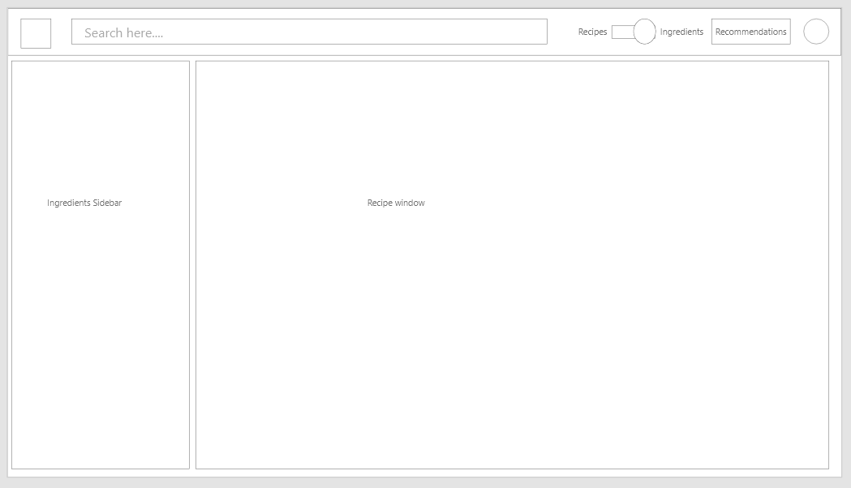

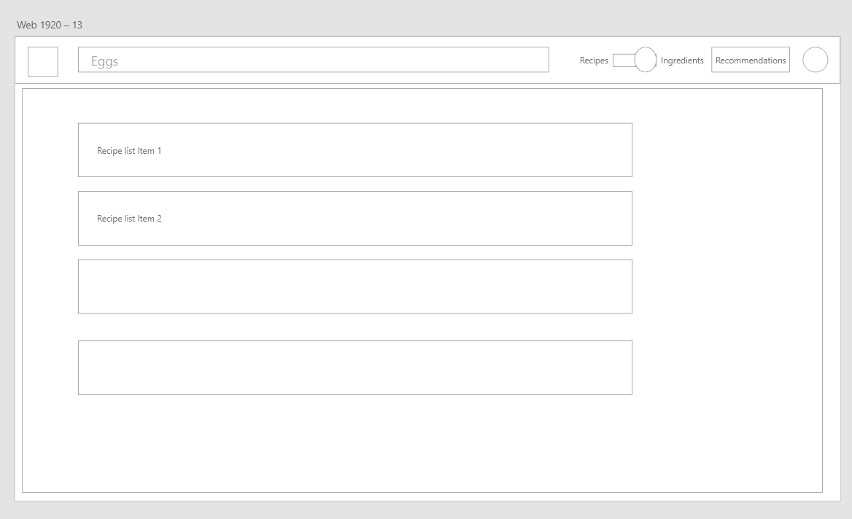

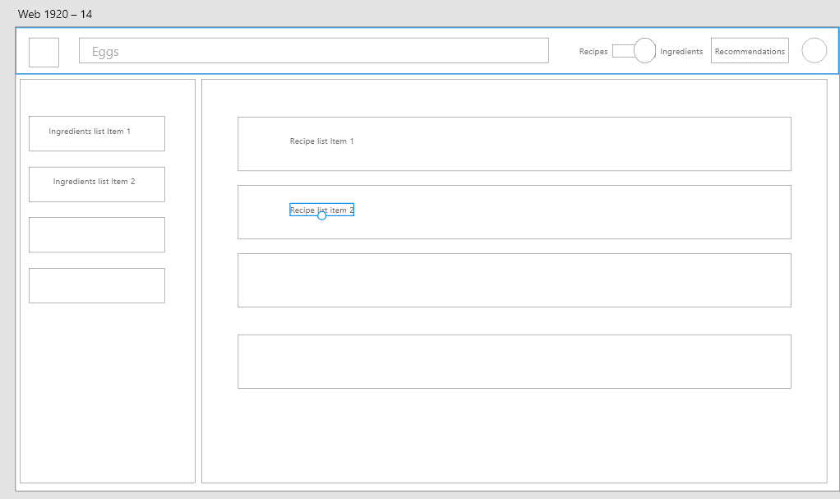On clicking the ingredient, recipes appear

**Registered:**

Emily:

* 1. Emily wishes to get a family recipe from Haley so she registered and asked Haley to do the same.

Haley opens her uploaded recipes page after logging in.

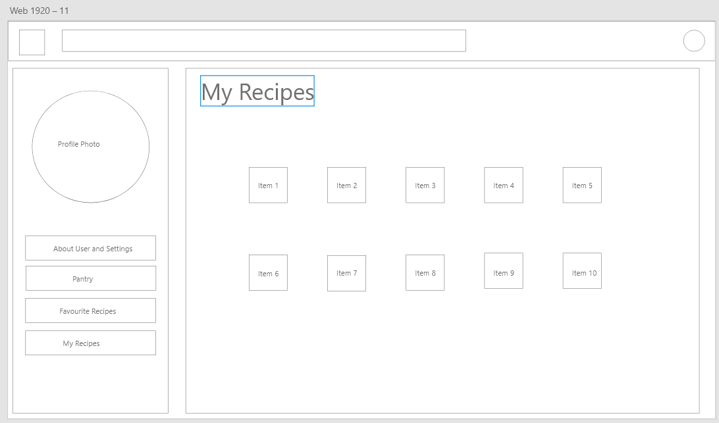

Selects a Recipe, shares it using Share Recipe button

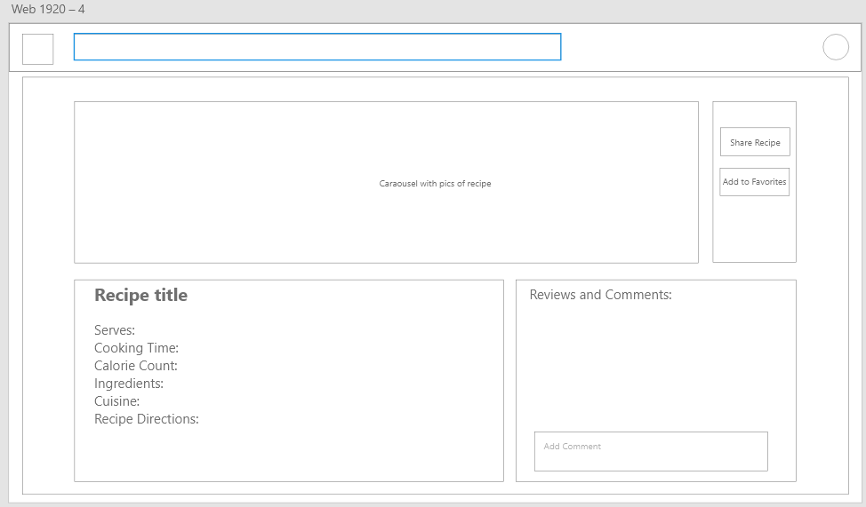

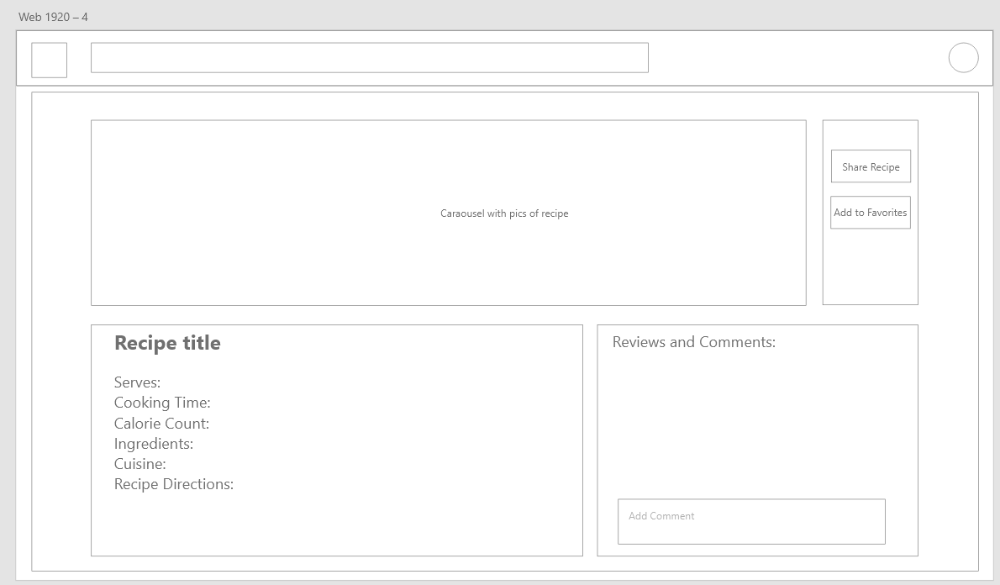Emily opens the recipe.

* 1. Haley decided to create an account with cookable because she wishes to share the family’s recipes with her niece Emily to cook. She finds it easy to sign up and then uploads her recipe to cookable and sent it to Emily.

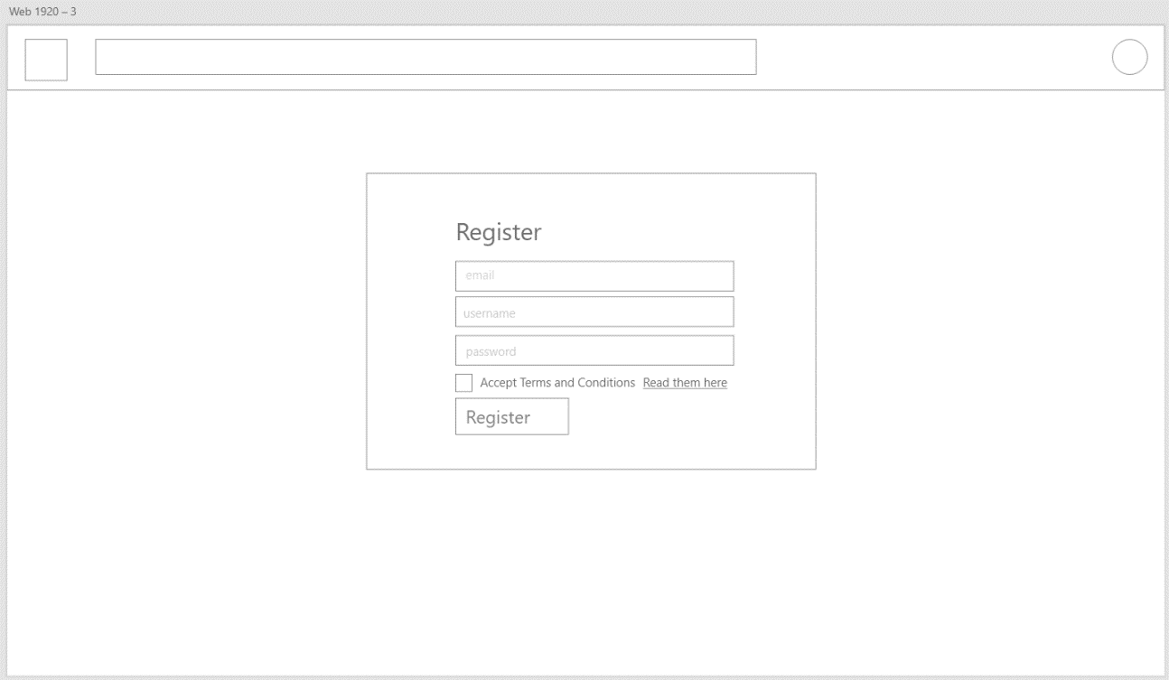She opens cookable.com Sign up page.

Registers herself and the site redirects to home page.

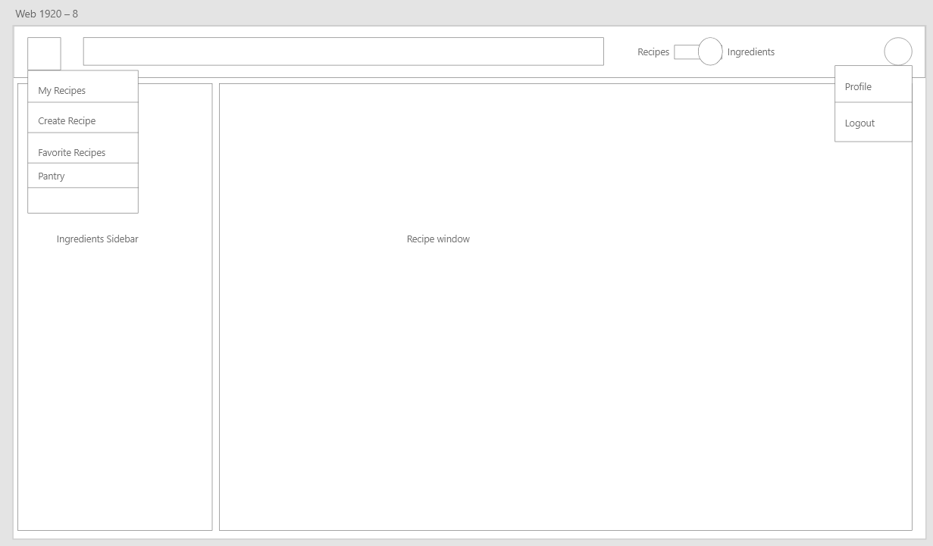

Uploads her recipe using Create Recipe option.

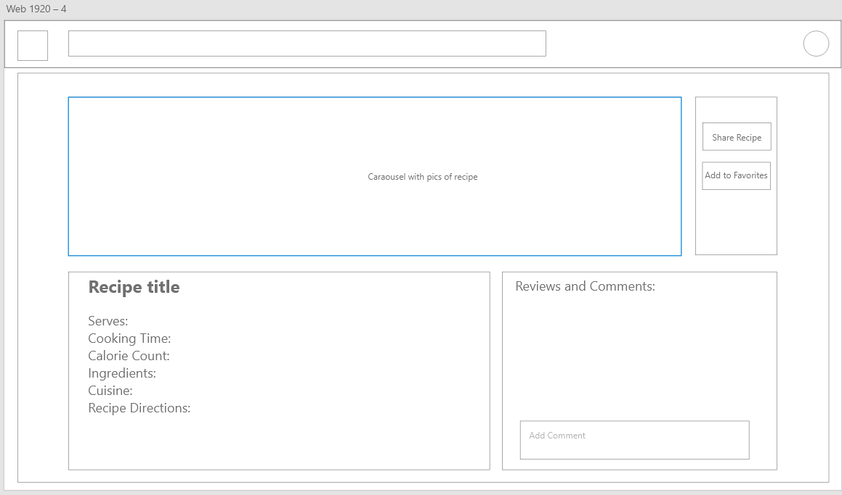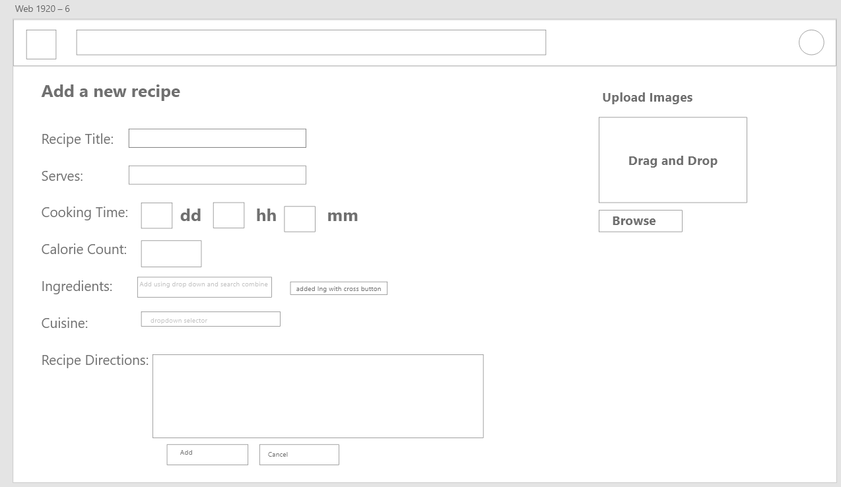Shares her recipe from recipe page.

* 1. Emily receives the recipe with the instructions and amount of ingredient needed to cook her family’s recipe and she has an easy to access grocery list.

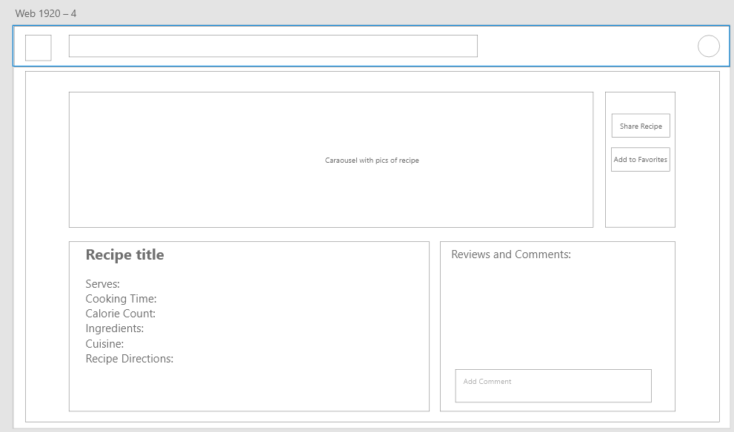The recipe page opens as shared by Haley.

And the Pantry checkup using the pantry page.

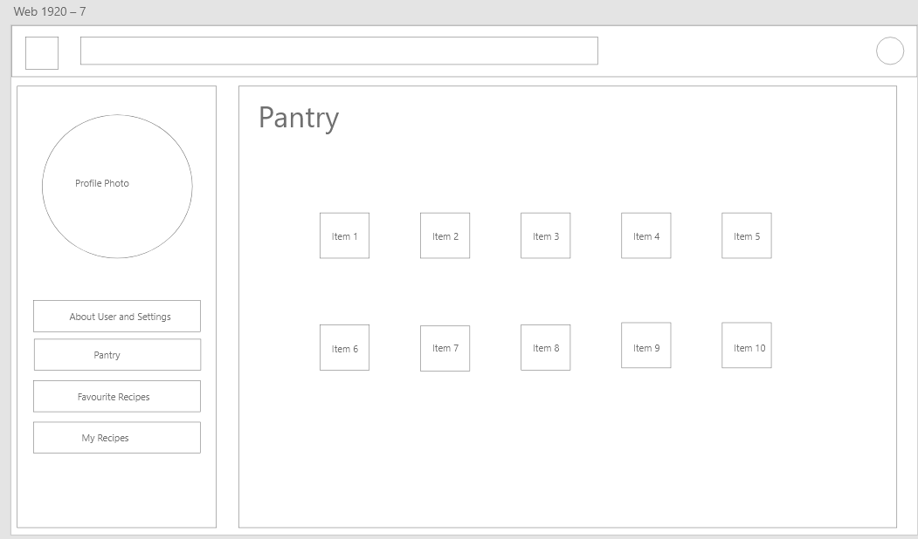

Clicking on the ingredient will take you to ingredient grocery list/to-buy page.

